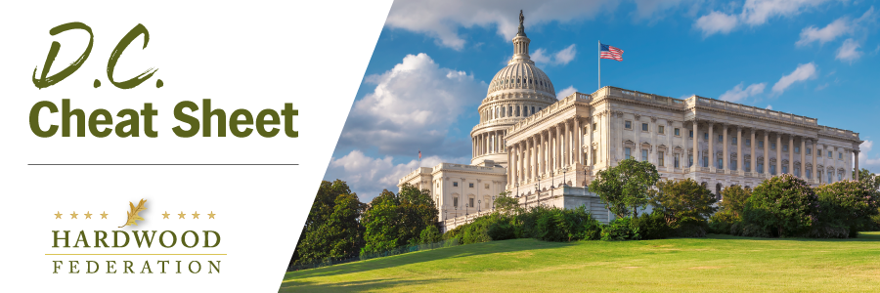

|  |  |  |  |
| --- | --- | --- | --- |
| |  |  |  | | --- | --- | --- | | |  | | --- | | ***Quick Updates from Your HF Team***    **Sen. Manchin Seeks HF Input During “Lame Duck” Session**    During a meeting with staff in the office of Sen. Joe Manchin (D-WV), the Federation discussed potential legislative efforts, new and existing, to promote the use of hardwood products within the context of low-carbon construction materials.  Building on the conversation, Senator Manchin’s staff requested recommended language that could be included within the “America’s Revegetation and Carbon Sequestration Act” (S. 4835), a bill that promotes carbon storage within federal buildings.  Senate staff mentioned that the Energy and Natural Resources Committee will mark-up S. 4835 at some point after the November election and solicited ideas on how to improve the bill moving forward.    **UN Study Predicts Increased Wood Consumption Trends**    The United Nations’ (UN) Food and Agriculture Organization has released a [report](https://u19539728.ct.sendgrid.net/ls/click?upn=-2B73de0dREQUDGWQfTM3mhuodzE8c9okH-2Bx3BF0z7DQqKk7LByWvJW4BuYzfUt908LCcyHGiv0R39cCF-2Bqb2mco93Gw2BHHhphqN7T2t3UrIgqIkL104fF0bc7U3nNdAkNj9QdfkCi0LG6gWhStmOq8opKHCVXO-2F8RR8ArbdDqLUEP8JMGzHdrckXxHNhU0d4--5J_DfShkWCAhoLGP-2FJNrdlPJdV-2FLULhdq7A2Mns4NO8kAbKoy2hBWCjup-2FdSJ4mtav3QZgwkC4yOhBCK4lj-2B12aQnJiZ34s26bQhfdnHDdOpt4JifzWSmexbyATavm0h6FOYPKPBpy3pJRgXKOba1jKr3fpnSRIuzEut-2B81YOTE-2B3RTidl1IKdETFPMNOJAKwoiVUS7NDtdUlnH6f06RgZCVyOrMfg6VtRSJIMZbJwQKOX7YkWRq4tCgjg1GhOAvWnHGFBxT6YyyAqt8iNlqwBsAiiRU34eXoITSPIAPVPMdxdnauNNEmrTZOwN-2BoeMjNRhgUEyMYOseScpU3pkPhjTQvx9ZDkQwQZ-2FEBYPQ5D2IAAzvO9ArcTQh5K00YMJDxe3GEifpb5V5S2-2FJfYVALJyntghHd-2BGRPgK8jIsHBwkav9Z0IzjObjenA8-2BYs29rdlhXNb5d-2FjXtsXIpPyf9Ti4jx38g4rvf9339-2BjkobneavUYmpXrlQIbtefCXdFcdbx8cbfEJrY5Lek0zHUgtIu9Nwgp9Doh7Bk5Q3mEsThdk-2FdFB0nrJi2jBP8bW-2Bzr2xx4g-2BhCDmo2YBATPeQmY-2F5UL1u2oy4vUdOKy7sZm1mlv6rb5LrpSiIVuPj3HmcqQTaKMoAyHFqtvJRZgc2bz-2BVcZw-3D-3D) showing that under a “business as usual scenario,” global demand for finished and processed wood products will increase by 37% by 2050.  The study characterizes wood as “renewable, recyclable, [and] climate friendly” and as a natural substitute for less sustainable materials.  The report also underscores the important role of effective forest management as a perquisite to meet demand by “encouraging wood production as part of land restoration programs and projects.”    **Hardwood Industry, Allies Urge Continued Labor Talks to Avoid Strike**    Today, the Hardwood Federation joined more than 250 industry allies in a [letter](https://u19539728.ct.sendgrid.net/ls/click?upn=NtcRpb7hfzXtNzaQ7M8AQPRZWfaErnDuOmnRR-2B4a280WNl1oiFiAxgtMmanqclphHXPE9LICfdh7iNdbutqONb-2F52sWQx-2ByNQ0NzJwz72W47fgwkQu3UYL940NgQBBc3Fgu-2BM-2B9yOwk16DoTqdomjeEjtJoKjf63iQln-2FQW-2FQpsilXW4uzFXsgKKid2MXaRvBvalzjxdNNtbidwUcy17dQ-3D-3DYivu_DfShkWCAhoLGP-2FJNrdlPJdV-2FLULhdq7A2Mns4NO8kAbKoy2hBWCjup-2FdSJ4mtav3QZgwkC4yOhBCK4lj-2B12aQnJiZ34s26bQhfdnHDdOpt4JifzWSmexbyATavm0h6FOYPKPBpy3pJRgXKOba1jKr3fpnSRIuzEut-2B81YOTE-2B3RTidl1IKdETFPMNOJAKwoiVUS7NDtdUlnH6f06RgZCVyOrMfg6VtRSJIMZbJwQKOX7YkWRq4tCgjg1GhOAvWnHGFBxT6YyyAqt8iNlqwBsAiiRU34eXoITSPIAPVPMdxdnauNNEmrTZOwN-2BoeMjNRhgUEyMYOseScpU3pkPhjTQvx9ZDkQwQZ-2FEBYPQ5D2IAAzvO9ArcTQh5K00YMJDxe3GEifpb5V5S2-2FJfYVALJyntghHd-2BGRPgK8jIsHBwkav9Z0IzjObjenA8-2BYs29rdlhXNb5d-2FjXtsXIpPyf9Ti4j6VUKRowjVad1DJML2N13bIZQ-2BZ95O7nV2qiyvv8Me0opCLorAuY0cFHcBAs7Dx2dLtgyiGy26gUddq21UnHUMQDl-2BCCq5Pdws69Rc83sbkJfJp2LZRSj6KuxaBstOPLESmDKPu1rUdsWlib1MlcxSm3Y4BB5igUhVVyj-2FpJ5tM10nEeJxwXx-2Fb2KMCjVzdd4A-3D-3D) to President Biden urging him to use the power of the bully pulpit to expedite a final agreement between the railroads and workers.  While industry applauds the President’s effective engagement earlier this fall resulting in a tentative agreement, the group cautions that recent rejection of the agreement could lead to a nationwide strike, paralyzing the nation’s transportation system.  Industry concludes that the Administration’s ability to avoid a strike in mid-September can be refocused to help push a final contract over the finish line. |  |  | | --- | | **Thoughts on the Cheat Sheet? Let us know at** [Hardwood.Federation@hardwoodfederation.com](mailto:Hardwood.Federation@hardwoodfederation.com)**!**    1101 K Street, NW, Suite 700, Washington, DC 20005 | | |