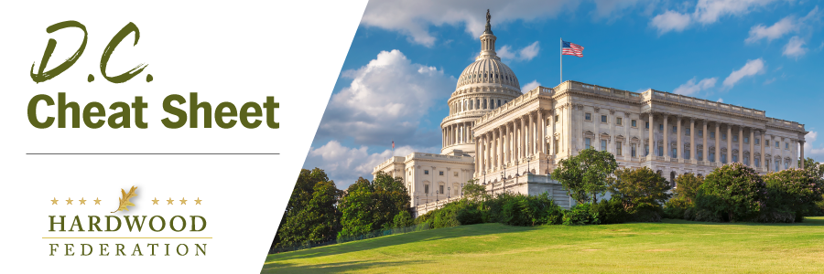

Quick Updates from Your HF Team

EU Moves Forward with Anti-Deforestation Rules

The three branches of the European Union (EU) all signed off on long-anticipated rules to ban imports of products, including U.S. hardwoods, originating from land linked to deforestation, including a geo-location requirement to zero in on a product’s precise location of harvest. The Hardwood Federation has been working closely with AHEC to raise concerns and provide the U.S. Department of Agriculture (USDA) with recommended language to address this problematic requirement. Both the Federation and AHEC joined a small group invitation-only call with USDA last week for an update on their efforts to address this and other issues U.S. exporters have identified regarding this new regulation. USDA assured us that our efforts have been well received and that proposed language has been sent to the USDA team in Europe to share with their E.U. counterparts. To read a statement from the EU Commission, please click here.

Senate Leadership in 2023, No Changing of the Guard

Although the House has reshuffled its leadership based on the outcome of the November election, in the Senate, preservation of the status quo is a mere formality. Although Senate Democrats are conducting formal elections in January, Sen. Chuck Schumer (D-NY) will carry on as Majority Leader. On the GOP side, Sen. Mitch McConnell (R-KY) successfully pushed back on a bid from Sen Rick Scott (R-FL) for the GOP’s top slot. Dick Durbin (D-IL) is expected to stay on as Majority Whip while his GOP counterpart, Sen. John Thune (R-SD), retained his position as Minority Whip during a vote on November 16.

Fish & Wildlife Service Conducts Webinar on New NLEB Rule

On December 2, the U.S. Fish and Wildlife Service (FWS) conducted a webinar to review general requirements for the new Northern Long-Eared Bat (NLEP) “endangered” classification. Unfortunately, the session was short on specifics related to possible future red tape for forestry projects. Federal regulators recommended, however, that industry send questions about specific projects to regional managers with the Ecological Services Program while informing industry that they will release more specific guidance in early 2023. Click here to see more information from FWS related to the NLEB.

