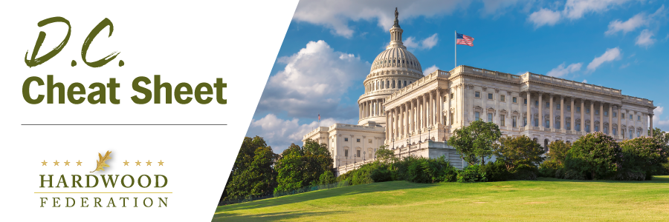

Quick Updates from Your HF Team
Easter Recess In Full Swing – Federal lawmakers are now at home for their traditional spring-time work period. As Congress considers the Farm Bill this spring, this is the perfect time to make your voice heard on some important priorities. If you see your federal officials at a public or private event, here are three key messages you can deliver to support the Hardwood Federation’s efforts at the federal level:
1. Grow Markets for Hardwood Products. We seek opportunities to build markets for hardwood products. Congress can promote high quality hardwoods and jobs through the farm bill:
• Establish a Hardwood Education Program. We all know that wood products are part of the climate solution. Hardwood floors, lumber and other products store carbon and prevent its release into the atmosphere. By establishing a hardwood education grant program, Congress can promote jobs in rural America while improving the environment.
• Expand International Markets. The hardwood sector is a powerful exporter of products “Made in the USA” and relies on foreign customers to support high quality jobs at home. To that end, remind your lawmakers of the importance of increased funding for the U.S. Department of Agriculture’s Market Access Program (MAP) and the Foreign Market Development (FMD) Program which support U.S. hardwood exports.
2. Oppose Tax Hikes that Harm American Hardwood Companies. The Federation supports favorable tax rates for small and medium sized businesses, including family-owned companies. It’s important to communicate the benefits of the small business tax deduction, flexible estate tax provisions and 100% expensing of equipment included within the tax reform law of 2017 and oppose any efforts to roll them back. To that end, tell Congress to support the ALIGN Act, introduced by Sen. Jim Lankford (R-OK) and Rep. Jodey Arrington (R-TX), which will make 100% expensing permanent.
3. Fix the Driver Shortage. Supply chains still aren’t fixed, largely because of the shortage of truckers on the road. Tell Congress to pass the bipartisan “Strengthening Supply Chains Through Truck Driver Incentives Act,” introduced by Reps. Mike Gallagher (R-WI) and Abigail Spanberger (D-VA). This important bill will tackle the trucker shortage by promoting apprenticeships to address recruitment challenges within a severely understaffed and rapidly aging sector.
Mark Your Calendar for Fly-In 2023!! REGISTER TODAY!
Make plans today to join us in Washington, D.C. June 13-15 for the 2023 Fly-In. Events will kick off with a welcome reception on the evening of Tuesday, June 13 followed by a full day of meetings on the Hill with your Congressmen and Representatives. We will host a PAC reception Wednesday night for our friends on the Republican side of the aisle and celebrate the day’s achievements over dinner. The Fly-in wraps up with a Thursday morning breakfast event recognizing the Democrats that support the hardwood industry. Check out the full schedule of events. You can sign up for the Fly-In and reserve your room HERE!
House Lawmakers Push “Resolution of Disapproval” to Revoke New NLEB Rule

On March 30, Rep. Pete Stauber (R-MN) introduced a “Resolution of Disapproval” under the Congressional Review Act (CRA) to rescind the U.S. Fish and Wildlife Service’s “endangered” listing of the Northern Long Eared Bat (NLEB) under the Endangered Species Act. In late November 2022, the USFWS finalized a rule reclassifying the NLEB from “threatened,” to “endangered,” thereby triggering more red tape for harvesting permits. Although the measure is likely to pass the House and may fare well in the Senate, it would require President Biden’s unlikely signature to cross the finish line.

