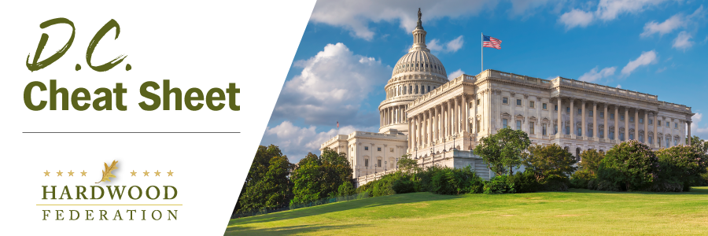

Quick Updates from Your HF Team

From Tuesday, June 13 through Thursday, June 15, the Federation Fly-In staged a comeback following a three-year hiatus in the wake of COVID measures that restricted access to Capitol Hill. More than 60 industry leaders conducted over 100 bipartisan, congressional meetings, advocating for hardwood priorities in the farm bill, tax legislation and transportation legislation.

Senate Advocacy Concentrates on Farm Bill Writers

While the farm bill dominated conversations in all congressional offices, industry leaders were able deliver key messages to nearly half the U.S. Senate, racking up 40 meetings. Highlights included discussions with nine of the 21 members of the Agriculture Committee, which is busy drafting its version of the farm bill. Conversations in the offices of Ag Committee Chair Debbie Stabenow (D-MI) and Ranking Member John Boozman (R-AR) figured prominently in the meeting series.

On the House Side, Timing Was Everything

Focusing on Members of Congress who represent districts where industry members live and work, the hardwood team conducted more than 60 meetings with House lawmakers from every region in the country. Because House-side committees recently passed tax and transportation packages that will likely move on the floor later this year, industry messages related to a business-friendly tax code and streamlining red tape that creates ongoing transportation bottlenecks were especially timely.

HFPAC Honors House-Side Champions

Although formal Hill meetings wrapped late on Wednesday afternoon of the 14th, on Wednesday evening more than 60 industry leaders headed to the Capitol Hill Club to thank House-side Republican friends of the industry. Following the reception, House Ag Committee Chair GT Thompson (R-PA) addressed the group during dinner and outlined a path forward for the farm bill. On Thursday, June 15, the Fly-In concluded with a breakfast reception, also on Capitol Hill where hardwood leaders were able to mingle with Democrat lawmakers who have a demonstrated track record of supporting the industry.

