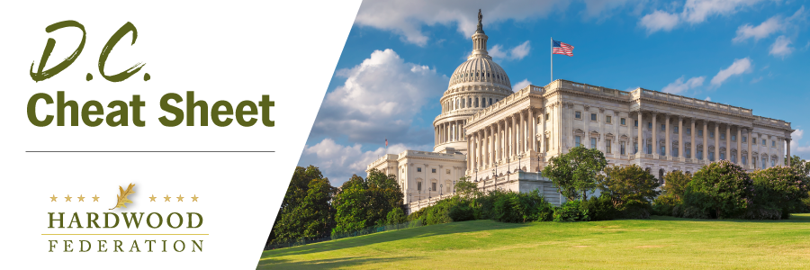

Quick Updates from Your HF Team

Sen. Daines Gears Up for Main Street Tax Certainty Act
The Hardwood Federation is joining dozens of other business groups in a letter endorsing “The Main Street Tax Certainty Act of 2023,” legislation to make permanent the 20-percent deduction for small and family-owned businesses. The tax reform law of 2017 established this important tax break, which is scheduled to sunset at the end of 2025. The letter cites recovery from the COVID-19 pandemic, inflation, labor shortages, and supply chain disruptions as ongoing challenges that warrant keeping the deduction in place.

Senate Votes to Rescind Bat Rule

On May 11, the Senate narrowly approved two measures that would overturn new ESA regulations on the Northern Long-Eared Bat (NLEB) under the Congressional Review Act. The first measure overturned the repeal of the Trump Administration’s definition of what qualifies as a protected habitat whereas the second measure rescinded the November 2022 reclassification of the NLEB as “endangered” rather than “threatened.” Although the House may take similar action on the NLEB, President Biden has already promised to veto the legislation that would reverse his Administration’s ESA policies.
NWFA and DHA Release Environmental Product Declarations
In November 2022, the Decorative Hardwoods Association and National Hardwood Flooring Association released two Environmental Product Declarations (EPD) outlining the “total cradle-to-grave global warming potential” for engineered wood flooring and solid wood floors. The EPDs show that natural wood floors have a significantly smaller carbon footprint than alternative materials such as ceramic tiles and various types of vinyl flooring and tiles. According to similar EPDs by the Resilient Floor Covering Institute, luxury vinyl plank wood-look flooring, for example, has a global warming potential that is nearly six times greater than engineered and solid wood floors.

Mark Your Calendar! The Federation Fly-In is Back, June 13 – 15, 2023
To sign up and reserve your room, please click HERE!.

