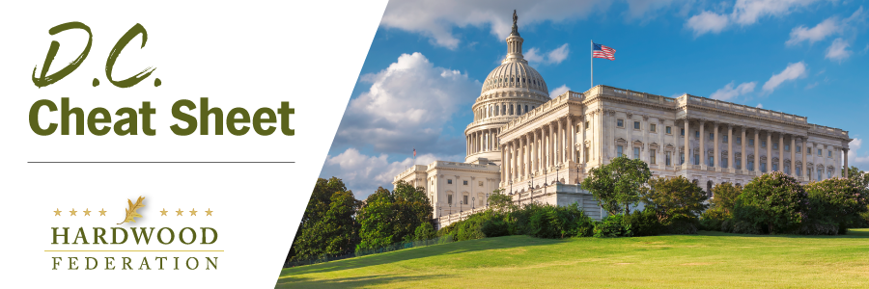
Quick Updates from Your HF Team

Congress Moves One-Year Farm Bill Extension
As the House finally passed a Continuing Resolution (CR) on Tuesday to fund federal programs beyond November 17 and into January, House Speaker Johnson (R-LA) worked with 209 Democrats and 127 Republicans to secure its passage. Speaker Johnson (R-LA), eager to kill two birds with one stone, crafted a CR that piggybacks a one-year extension of the 2018 Farm Bill that will guarantee funding for key hardwood initiatives such as the Market Access and Foreign Market Development programs until September 30, 2024. The Senate is expected to take up the measure and pass it before funding for federal agencies expires on November 17. The Federation will keep you posted on developments as they unfold.
Hardwoods, Small Business Allies Oppose Corporate Transparency Act Mandates
The small to medium sized business community is once again reaching out to Congress to delay implementation of the Corporate Transparency Act (CTA), a little-known federal anti-corruption law enacted in 2021 that takes effect in a little over a month and a half. HF has signed on to a previous letter to House and Senate leadership asking for an implementation delay but given the compliance date is just weeks away the pressure is building. The American Institute of Certified Public Accountants (AICPA) sent this letter to the Financial Crimes Enforcement Network, the implementing federal entity at the Department of Treasury, on October 30 outlining its concerns with FinCen sticking with the statutory deadline for compliance. The issue is CTA’s multiple reporting requirements have not been well socialized. HF has agreed to sign the letter, which will be sent to House and Senate leadership this week.
Forest Service Delivers Update on Mature, Old Growth Forests
On November 8, the Forest Service presented the findings of their threat assessment for mature and old growth forests (MOG), which identifies wildfires and pest infestation as the leading causes of old growth forest loss. The presentation follows review of input received on USDA proposals this year related to climate resilient forests, on which the Federation submitted comments this summer. Next steps include delivery of a report from USFS on threats to MOG during the winter of 2024 and development of a related conservation plan later next year. At this time, industry stakeholders are viewing the USFS findings as another justification for improving forest management to reduce wildfire and infestation risk.

