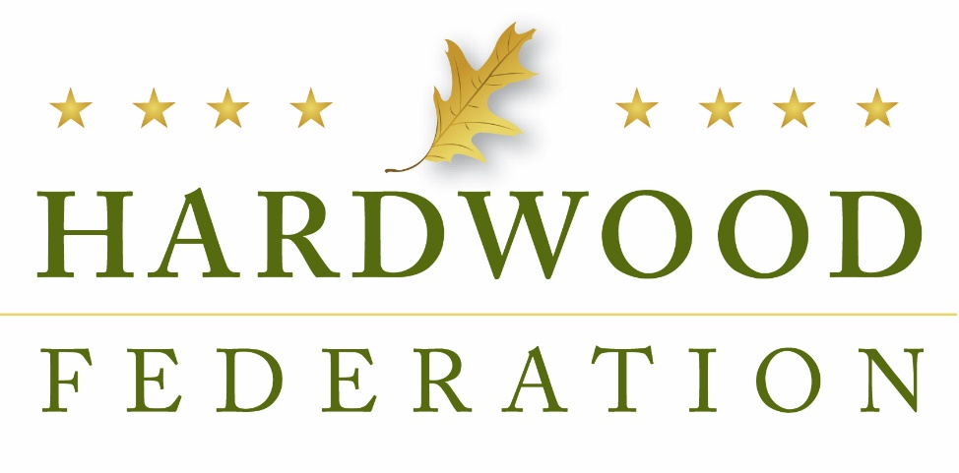
Hardwood Federation - October 2022 Newsletter

From the Executive Director: “Lame Duck” Congress May Look at End-of-Year Tax Breaks

With only eight days left before Election Day, Congress has long-since left the capital to hit the campaign trail. While the Senate had originally scheduled a two-week session for October, on September 29, Sen. Majority Leader Chuck Schumer (D-NY) canceled the session and informed colleagues that the chamber would not convene again until November 14. The House, on the other hand, has never been scheduled for an October session and is also expected to convene November 14.

Like the rest of Washington, and the country, the Hardwood Federation team will be tuned into return results on November 8, but we have not lost focus on potential action when the sitting Congress returns to D.C. on November 14. One of the agenda items for Congress after the election will be to consider extension of a variety of tax breaks that are due to expire on December 31. This includes 100% bonus depreciation of equipment, a tax break enshrined in the tax reform law of 2017 that incentivizes investment in sawmills and other manufacturing facilities. Momentum for an end-of-year tax package is building, especially as industry groups including the National Association of Manufacturers send letters urging Congress to act when they return after the mid-term elections. Because the hardwood industry relies on 100% expensing of its heavy-duty equipment - a provision which will begin to decline by 20% each year on January 1, 2023 until it is completely depleted - the Federation is drafting a letter to key tax writers in Congress urging lawmakers to extend the deduction within the context of any tax package that might come together before the end of the year.
Other issues that could come up are covered below and the Federation will stay on task and weigh in on those issues most important to the industry as we enter into the final days of the 117th Congress.

Issues:

Sen. Manchin, Energy Committee Staff, Seek HF Input During Lame Duck Session
During a meeting with staff in the office of Sen. Joe Manchin (D-WV) on October 19, the Federation discussed potential legislative efforts, new and existing, to promote the use of hardwood products within the context of low-carbon construction materials. Building on the conversation, Senator Manchin’s staff requested recommended language that could be included within the America’s Revegetation and Carbon Sequestration Act (S. 4835), a bill that promotes carbon storage within federal buildings. Senate staff mentioned that the Energy and Natural Resources (ENR) Committee will mark-up S. 4835 at some point after the November election and solicited ideas on how to improve the bill moving forward. During a follow-up meeting with GOP counterparts on the ENR committee on October 27, Senate staff expressed a willingness to look at provisions that focus on wood products as a low-carbon construction material.
Senate Duo Wades Into NDAA, Mass Timber Discussion

Senate Armed Services Committee Chair Jack Reed (D-RI) and Ranking Member Jim Inhofe (R-OK) opened a brief legislative session October 11 to begin moving the National Defense Authorization Act (NDAA), a bill that funds the nation’s defense priorities. This bill is also a priority for the Lame Duck session. The House passed its version of the bill in July, which includes an industry-supported program for mass timber construction projects. Because Senators Reed and Inhofe punted full consideration of the bill to November, following the election, it remains to be seen whether the industry amendment makes the final cut.
Administration Tasked with Mediating Labor Talks, Dodging Transportation Meltdown
On October 27, the Hardwood Federation joined more than 300 industry allies in a letter to President Biden urging him to use the power of the bully pulpit to expedite a final agreement between the railroads and workers. While industry applauds the President’s effective engagement earlier this fall resulting in a tentative agreement, the group cautions that recent rejection of the agreement could lead to a nationwide strike, paralyzing the nation’s transportation system. In mid-October, railway workers rejected a framework for a labor agreement, citing paid time off as a key item for continued talks. That said, industry concludes that the Administration’s ability to avoid a strike in mid-September can be refocused to help push a final contract over the finish line.
Complicating the prospects for continued transportation challenges, dock workers on the west coast have been working without a contract since May. This illustrates the juggling act being conducted by the Administration, which continues to work to broker labor agreements. Without final deals, manufacturers and the transportation sector can’t make long-term plans necessary to bring an end to supply change challenges.
Wisconsin Senator Introduces Reliable Rail Service Act

While the Administration confronts immediate challenges facing supply chains, at least one Senator is looking ahead for more long-term solutions. On September 27, Sen. Tammy Baldwin (D-WI) introduced the Reliable Rail Service Act, a bill to help untangle supply chain bottlenecks plaguing the hardwood industry and other shippers around the country. The bill aims to codify requirements that rail carriers provide service to a broad swath of users, including the hardwood sector, “on reasonable request.” While a path forward for the bill is limited this year, the legislation lays down an important marker to be picked up in 2023 when a new Congress convenes and considers measures to re-balance the nation’s supply chains.

Senate Energy Panel Reviews Forest, Lands Bills

On September 29, the Senate Energy and Natural Resources Committee conducted a hearing to review several forest bills intended to expedite effective management practices. Committee Chairman Joe Manchin (D-WV) noted that “past mismanagement … has ushered in an era of fuels and wildfires” and that “reduced harvesting has led to historic buildups of vegetation [and] fuel loads.” For example, lawmakers reviewed the “Small Timber and Underutilized Materials Act,” among others, that would cut red-tape for commercial projects on public lands. Senate staff informed the HF team during a meeting on October 19 that they are characterizing the bundling of these bills as a “forestry package,” terminology more specific than the “lands packages” that have moved in recent years. To view a list of the bills examined by the panel, please click here.

Rep. Stauber (R-MN) Pushes Back on New USFWS Restrictions

On October 6, Rep. Pete Stauber (R-MN) sent a letter, which included six GOP colleagues as signatories, to the U.S. Fish and Wildlife Service (USFWS), urging the agency to drop additional restrictions made to the Lakes States Habitat Conservation Plans (HCP) for bat species. The letter states that the “bat species being targeted by these restrictions are not harmed by sustainable forest management” and that healthy forest management actually mitigates the harm intended to be addressed by the new rules. The lawmakers go on to urge regulators to avoid taking steps that would damage local economies, which they point out as an “unintended consequence” of the agency’s action.

UN Study Predicts Increased Wood Consumption Trends
The United Nations’ (UN) Food and Agriculture Organization has released a report showing that under a “business as usual scenario,” global demand for finished and processed wood products will increase by 37% by 2050. The study characterizes wood as “renewable, recyclable, [and] climate friendly” and as a natural substitute for less sustainable materials. The report also underscores the important role of effective forest management as a perquisite to meet demand by “encouraging wood production as part of land restoration programs and projects.”

